

**International School**

**Capstone Project 1**

CMU-SE 450

**Interface Design Document**

**Date: 15/03/2023**

**LinguaSnap for Travelers**

**Submitted by**

**Dat, Nguyen Thanh**

**Truong, Vu Dinh**

**Long, Pham Ba Hoang**

**Kha, Nguyen Ngoc**

**Approved by Nguyen Duc Man**

**Proposal Review Panel Representative:**

Name S ignature Date

**Capstone Project 1- Mentor:**

Name Signature Date

**PROJECT INFORMATION**

|  |  |  |  |
| --- | --- | --- | --- |
| **Project acronym** | LiS | | |
| **Project title** | LinguaSnap for Travelers | | |
| **Start date** | 25 – February – 2023 | **End Date** | 31 – May – 2023 |
| **Lead institution** | International School, Duy Tan University | | |
| **Project mentor** | Nguyen Duc Man  Email: mannd@duytan.edu.vn  Phone: +84 904 235 945 | | |
| **Partner organization** | Duy Tan University | | |
| **Scrum Master** | Dat, Nguyen Thanh | ntdat1232001@gmail.com | 0972530969 |
| **Product owner** | Truong ,Vu Dinh | longphambahoang@gmail.com | 0793310221 |
| **Team members** | Kha, Nguyen Ngoc | winkha14567@gmail.com | 0945721427 |
| Long, Pham Ba Hoang | jonnyvu2210@gmail.com | 0905223611 |

REVISION HISTORY

|  |  |  |  |  |
| --- | --- | --- | --- | --- |
| **Version** | **Date** | **Comments** | **Author** | **Approval** |
| 1.0 | 15/03/2023 | Initial Release | Long, Pham Ba Hoang |  |

# 

# Introduction

## Purpose

* This document serves the purpose of specifying application’s UI design

## Scope

* Create complete interfaces, and describe them clearly.
* Overview of the stages and modules of the system

# Describe User Interface Application in Detail

### UI-01:Login

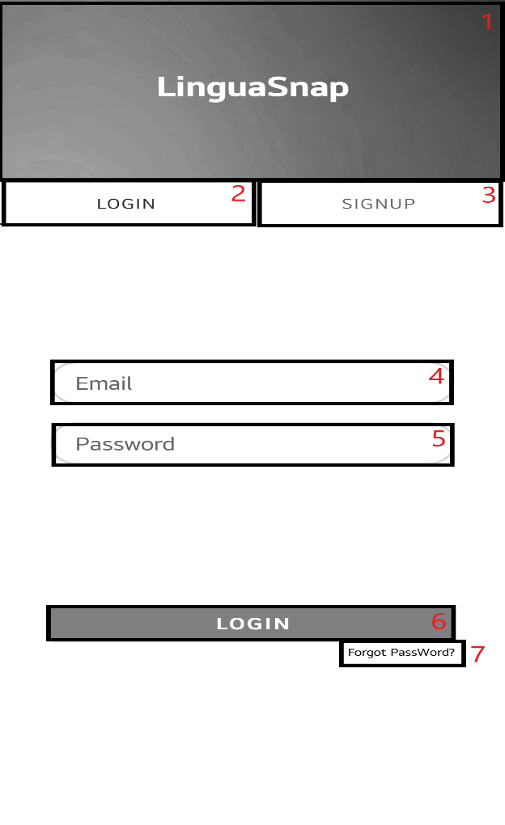

|  |  |  |  |  |
| --- | --- | --- | --- | --- |
| **ID** | **Condition** | **Control Type** | **Target** | **Notes** |
| 1 | Nothing | Text | Logo of app |  |
| 2 | Click | Button | Login Page |  |
| 3 | Click | Button | Sigup Page |  |
| 4 | Click | Text box | Enter email |  |
| 5 | Click | Text box | Enter password |  |
| 6 | Click | Button | Login |  |
| 7 | Click | Button | Forgot password |  |

### UI-02:Signup

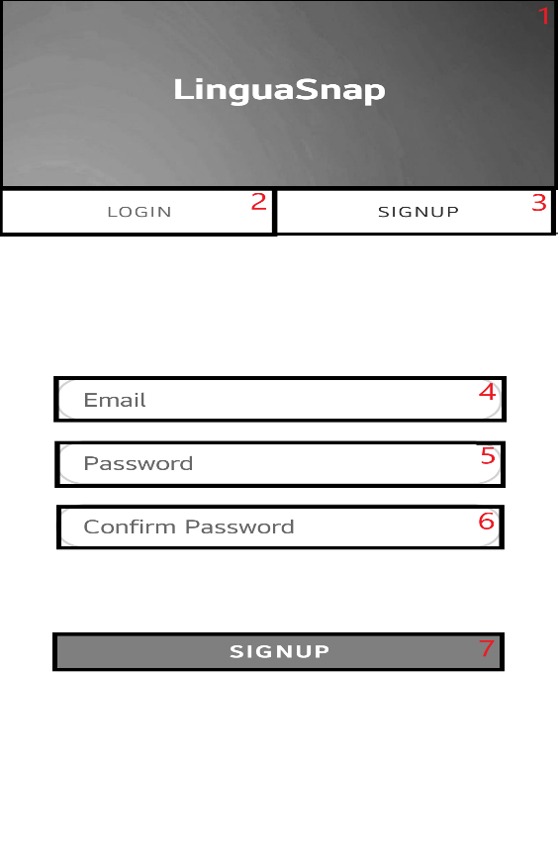

|  |  |  |  |  |
| --- | --- | --- | --- | --- |
| **ID** | **Condition** | **Control Type** | **Target** | **Notes** |
| 1 | Nothing | Text | Logo of app |  |
| 2 | Click | Button | Login Page |  |
| 3 | Click | Button | Sigup Page |  |
| 4 | Click | Text box | Enter email |  |
| 5 | Click | Text box | Enter password |  |
| 6 | Click | Text box | Enter confirm password |  |
| 7 | Click | Button | Signup |  |

### UI-03:Forgot Password

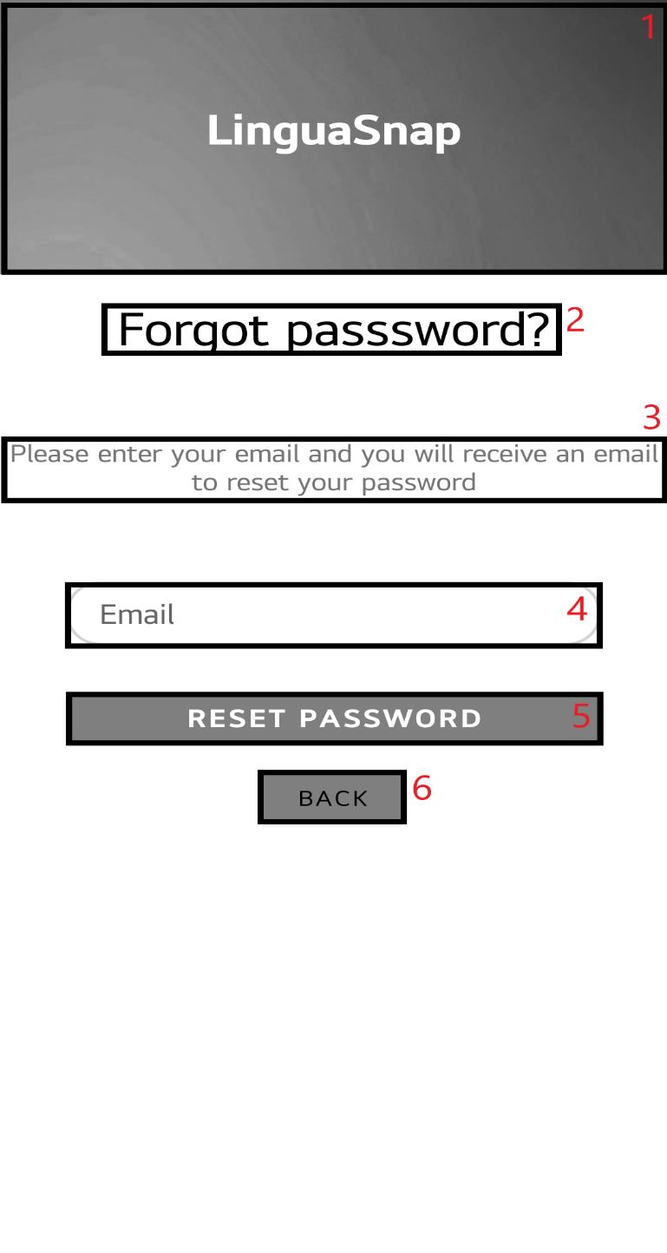

|  |  |  |  |  |
| --- | --- | --- | --- | --- |
| **ID** | **Condition** | **Control Type** | **Target** | **Notes** |
| 1 | Nothing | Text | Logo of app |  |
| 2 | Nothing | Text | Forgot Password |  |
| 3 | Nothing | Text | Guide forgot password |  |
| 4 | Click | Text box | Enter email |  |
| 5 | Click | Button | Forgot password |  |
| 6 | Click | Button | Back to login page |  |

### UI-04: Menu

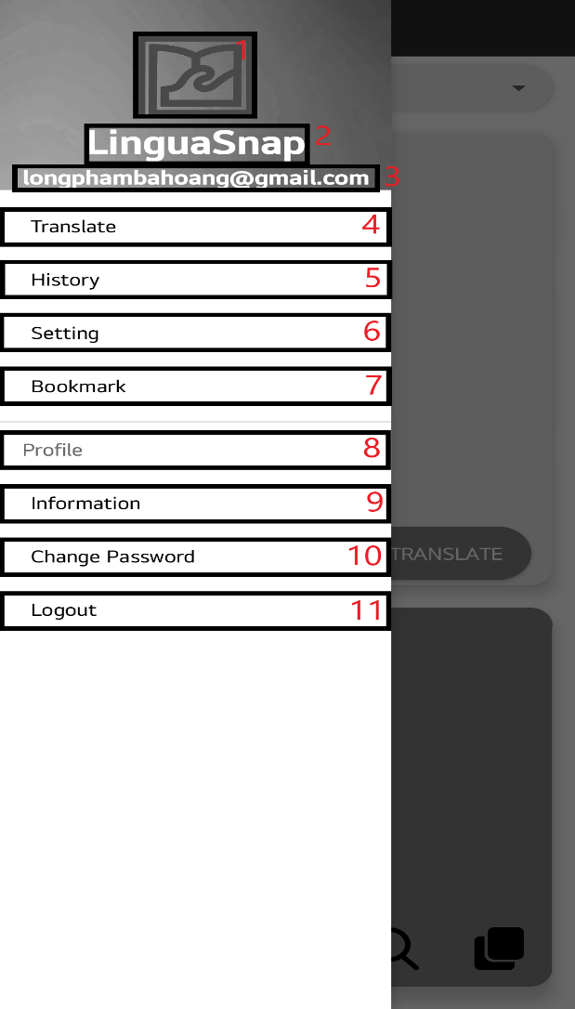

|  |  |  |  |  |
| --- | --- | --- | --- | --- |
| **ID** | **Condition** | **Control Type** | **Target** | **Notes** |
| 1 | Nothing | Picture | Logo of app |  |
| 2 | Noting | Text | Logo of app |  |
| 3 | Nothing | Text | Email of user |  |
| 4 | Click | Button | Translate page |  |
| 5 | Click | Button | History page |  |
| 6 | Click | Button | Setting page |  |
| 7 | Click | Button | Bookmark page |  |
| 8 | Nothing | Text | Profile |  |
| 9 | Click | Button | Information page |  |
| 10 | Click | Button | Change password page |  |
| 11 | Click | Button | Logout |  |

### UI-05: Translate

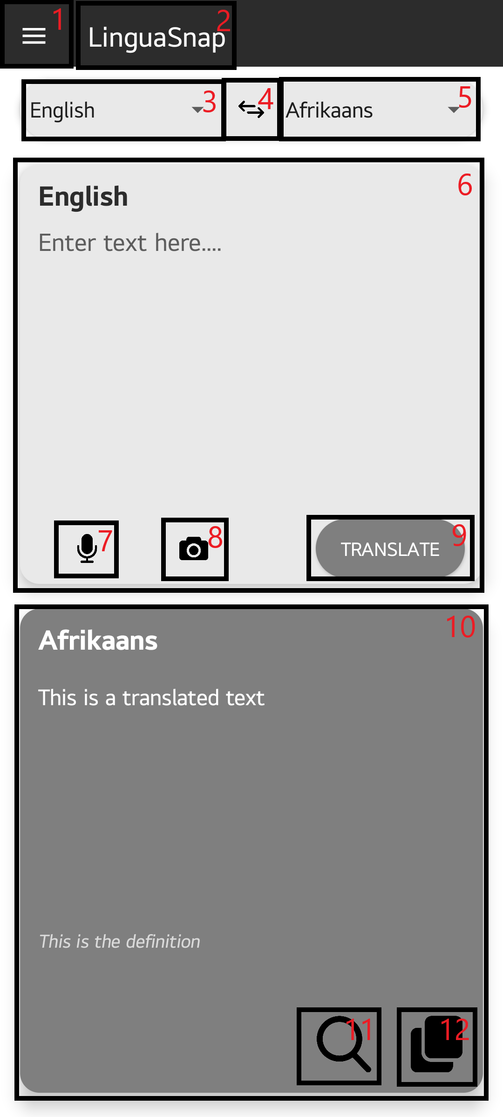

|  |  |  |  |  |
| --- | --- | --- | --- | --- |
| **ID** | **Condition** | **Control Type** | **Target** | **Notes** |
| 1 | Click | Menu | Menu of app |  |
| 2 | Nothing | Picture | Logo of app |  |
| 3 | Click | Spinner | 'From' Language selection |  |
| 4 | Click | Button | 'Reverse' Language |  |
| 5 | Click | Spinner | 'To' Language selection |  |
| 6 | Click | Text box | Enter the language you want to translate |  |
| 7 | Click | Button | Voice input language |  |
| 8 | Click | Button | Enter language from pictures |  |
| 9 | Click | Button | Translate Language |  |
| 10 | Nothing | Text box | Translated language |  |
| 11 | Click | Button | Search for translations on the internet |  |
| 12 | Click | Button | Copy translation |  |

### UI-06: Camera

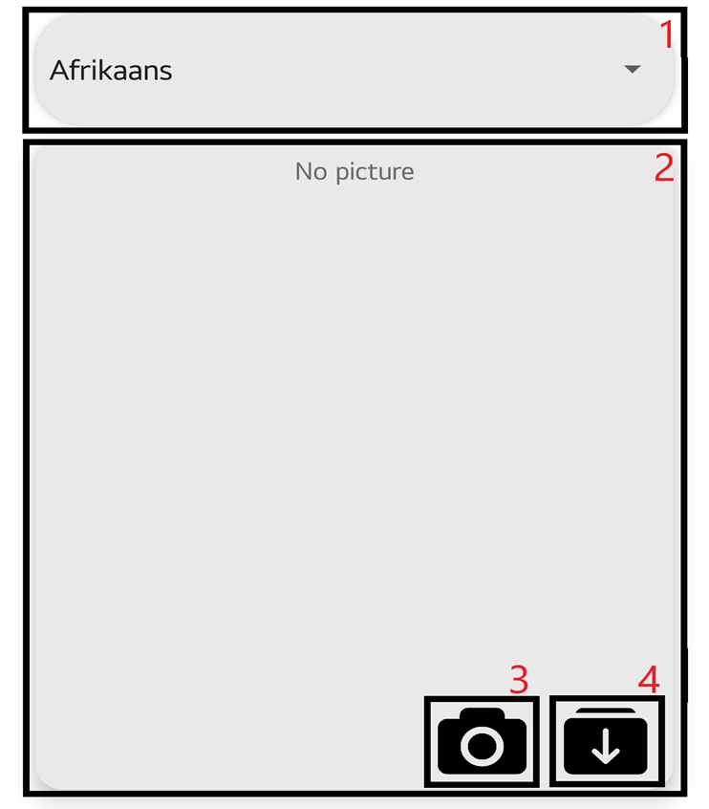

|  |  |  |  |  |
| --- | --- | --- | --- | --- |
| **ID** | **Condition** | **Control Type** | **Target** | **Notes** |
| 1 | Click | Spinner | 'From' Language selection |  |
| 2 | Nothing | Picture | No picturex |  |
| 3 | Click | Button | From the Camera |  |
| 4 | Click | Button | From the gallery |  |